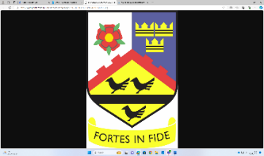


ST JOHN WALL CATHOLIC SCHOOL
YEAR 10 WORK EXPERIENCE 2026
CONSENT FORM
Please return completed consent form to Mr Rathbone by
Tuesday 16 December

Pupil name (print): ____________________________________________________ Form: ______________

Student Consent

I agree to take full part in my work experience. I will not pass on any information about the business to another person without the employer’s permission. I agree to observe all safety, security and other rules explained to me or displayed where I work.

Pupil signature: ____________________________________________________ Date: _______________

Parent/Carer Consent

My child does/doesn’t* have a medical condition that could result in an unnecessary risk to his/her health & safety or of others within the workplace. If you answered ‘does’ please describe the condition below:

Medical Condition: _______________________________________________________________________

My child does/doesn’t* have a criminal conviction. If you answered ‘does’ please indicate the nature of the conviction in the space below. Please consult the Learn to Work Team if you have any concerns or questions.

Criminal Conviction: ______________________________________________________________________

Pupils may be photographed during work experience for the purpose of assessment, publicity and training. Please tick the appropriate box and sign below if you agree to your child being photographed during their work experience placement.

Photographed by School only Photographed by School and Employer

I the parent/carer* of the above named student agree to my child participating in the school’s work experience programme. I agree that he/she* should observe the conditions set out by the school and the employer.

Parent signature: ___________________________________________

Parent name: ___________________________________________ Date: _______________________

Please supply one or more phone number in case we need to contact you in an emergency during work experience week:

Parent contact number(s) __________________________________________________________________

