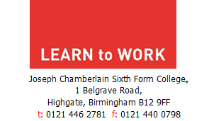

December 2025

Dear Parent(s)/Carer(s)

Re: Year 10 Work Experience Programme 2026

This year School will be running a work experience programme for students in Year 10. As part of the work related learning curriculum, work experience is an entitlement for all students. St John Wall will be partnering with ‘Learn to Work’ Limited to help organise and deliver work experience and the programme for Year 10 students will run from Monday 4 to Friday 8 May 2026.

Pupils may have already found their employer, or will soon be allocated to one, and some will attend the workplace for a ‘pre-placement interview’ before their placement starts.

In order for your child to attend their work experience placement, parents/carers must complete and sign the consent form attached. All signed consent forms must be returned to Mr Rathbone in school by Tuesday 16 December 2025. Please note your child will not be allowed to participate in work experience without a signed parental consent form.

It is essential that you and your child read through the enclosed information booklet, which will help you to better understand work experience and answers most frequently asked questions about the programme.

For any further information regarding work experience, please do not hesitate to get in touch with me or any member of ‘Learn to Work’ on 0121 446 2781.

Yours faithfully
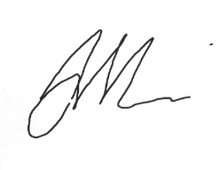

Mr A Marshall
‘Learn to Work’ Team Manager

Encs

